Notas fiscais eletronica exploration

Introduction

The language used to develop this challenge was R. The dataset used in this analyze was found at this address: [https://github.com/TOTVS/MDMStatic/blob/master/code-challenge/TOTVS%20Labs%20-%20AI%20Challenge%20-%20Dataset.zip?raw=true.](https://github.com/TOTVS/MDMStatic/blob/master/code-challenge/TOTVS%20Labs%20-%20AI%20Challenge%20-%20Dataset.zip?raw=true. )

The goal is predict how much a customer will spend and the sales forecast for the next week. It is possible you have one nota fiscal for a group of people (customers). I am considering on this analyze, for each nota fiscal there is one customer.

Analysis

It was necessary to create two dataset. The first one has the nota fiscal data and the second has the product data. The nota fiscal data dataset has 1635 and the product dataset has 3547 observations from the nota fiscal electronica. Both dataset has some attributes shared (mesa, dataemissao and week) which allows us to cross search in both dataset.

**Product dataset.**

There are 1635 observation where the product the customer had is a buffet, consequently every “nota fiscal” buffet product.

The next two histograms show the distribution from the total spent by notal fiscal and the price of the buffet.

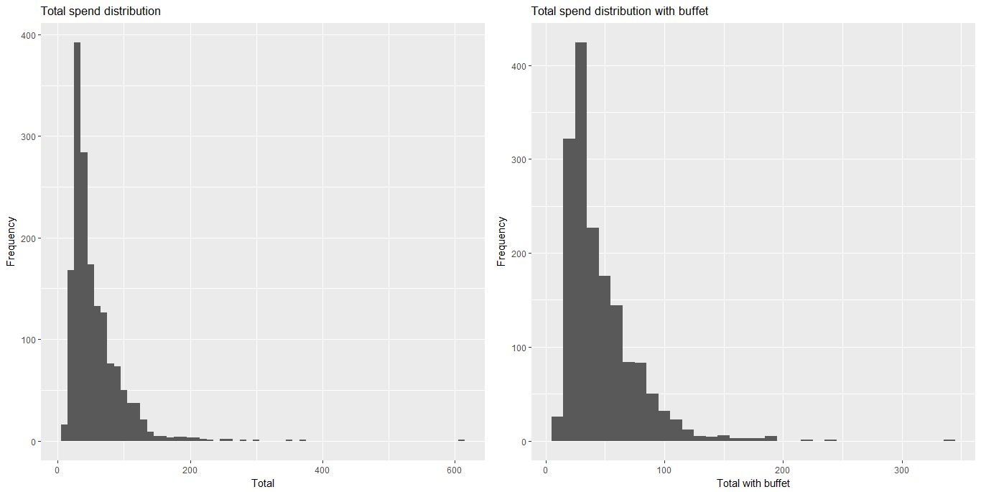

Both distribution is very similar. They have distribution positively skewed with some outliers’ prices.

After filtered the products with price above 200, there were 4 observations, 3 buffets and one Sushi Especial. These outliers could be mistyped value, because they are higher above the price product mean, 25.58, however, it also can be a family or group of people together due the amount of product in the nota fiscal.

Based on the distribution from the last two histogram, I think the product dataset can be disregarded. From now on, I am going to use just the nota fiscal dataset.

**Nota fiscal dataset.**

Valortotal is the property name from the total spend by nota fiscal in the dataset.

Analyzing the nota fiscal dataset, two histogram was create to describe the valortotal distribution.

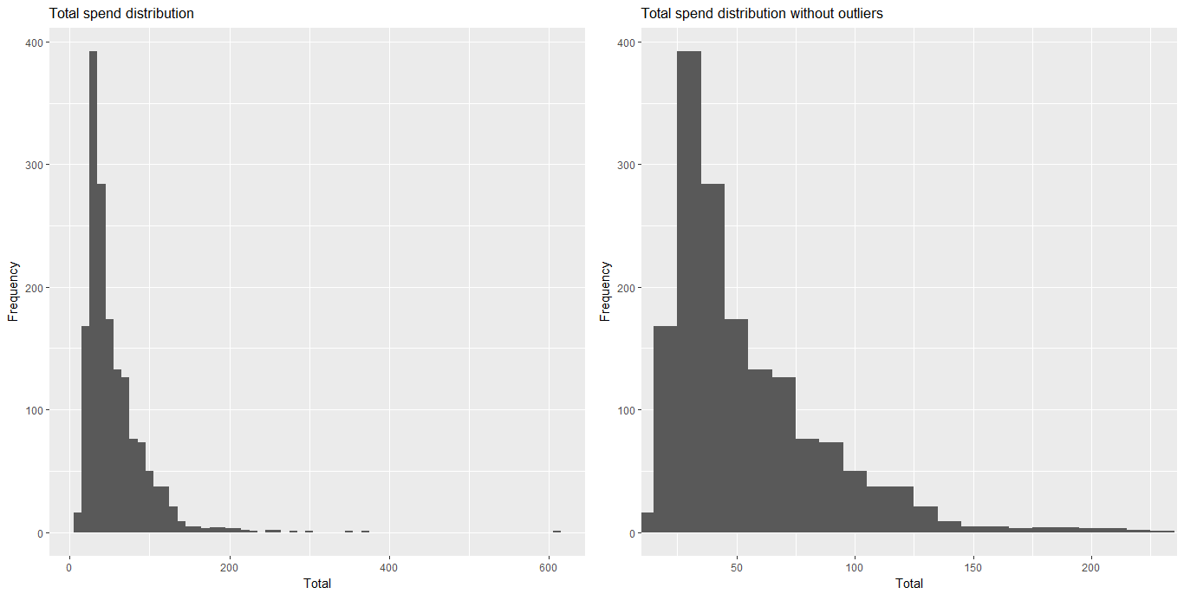

They show a distribution positively skewed and the first one shows the data with the outliers and the second disregards them. Values above 226 have just 10 observations, so I considered them outliers.

**Predicting the value spend by nota fiscal.**

The next histogram chart has the same dataset without outlier and it was applied the log10 to x-axis, and now it is close a normal distribution.

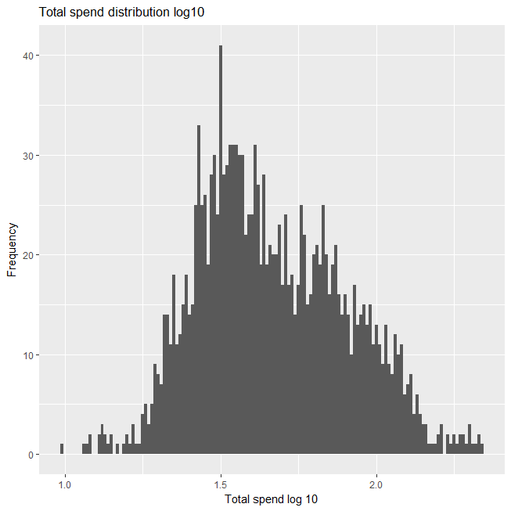

The rules for normally distributed data says 2 standard deviation below and above the mean represent around 95% from the population.

Applying the log 10 for valortotal, we have:

Mean = 1.673;

Standard deviation = 0.243;

95% of the nota fiscal valor total are from 15.66 (1.194) to 136.66 (2.135) with the mean 47.09 (1.673).

**Predicting the sales forecast for the next week.**

The next image shows 3 scatters diagram from valortotal by week without outliers.

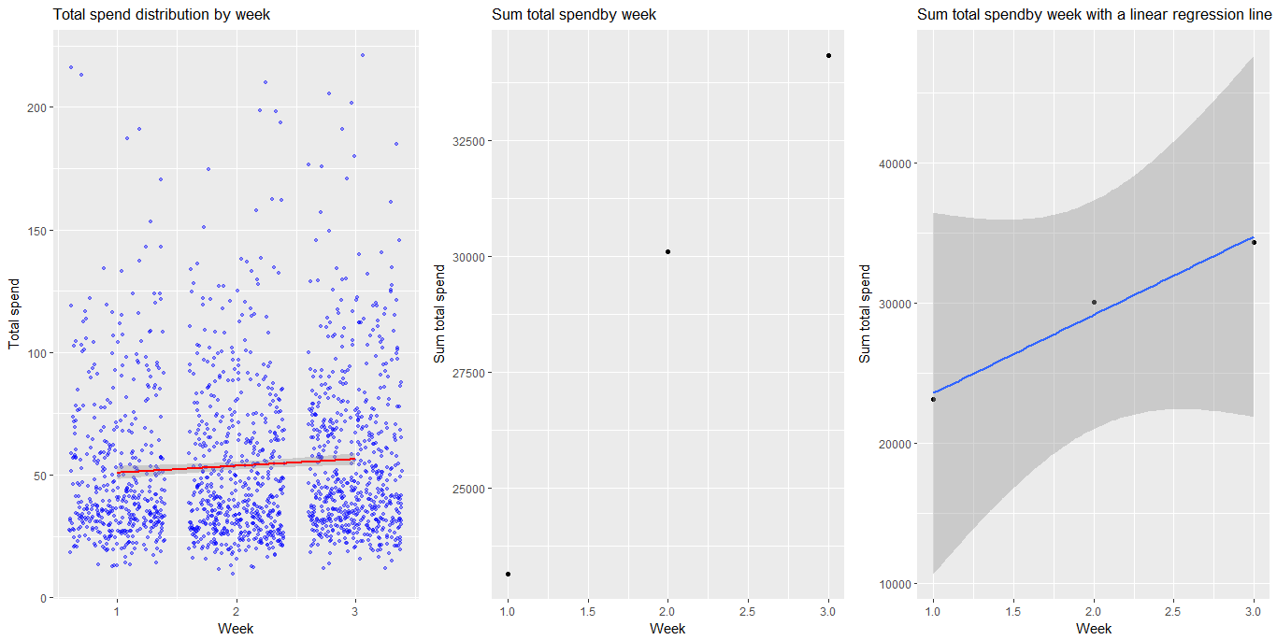

The first diagram shows the distribution from the values and its concentration by week. I figured out a small increase from the first week to second week and from the second to the third week. The red line better represent this increase. Then, in the second diagram, the sum of all the values was plotted by week and it is clear a positive linear correlation. In the third diagram, a linear regression line was drawn and the points is very close to the line.

Based on the third chart, I figured out that it is possible to use linear regression to predict the sales forecast for the next week.

Using lm function from r language, I found the r-square, the fit value and the confidence interval.

R-squared is around 98.06% (0.9896), what indicate the variance of the week predicts the sum of the values spend by nota fiscal.

The total sum (fit value) is 40371.57, and the confidence interval is from 14603.75 to 66139.40.

**Restaurant’s best location**

The dataset has an additional information informing the table (“mesa”) where the customer sit. The frequency can indicate the best place from the restaurant area.

The table named “mesa 22” has a frequency of 26, followed by the mesa 36, mesa 1 (25), mesa 10 (24), mesa 21 (24), mesa 4 (24), mesa 5 (24), mesa 7 (24). This location is chose by more than 10% of the nota fiscal. There isn’t enough information if this table are close from each other, but this information can be important to help to distribute the waiters in the restaurant area.

**Conclusion.**

After analyzing the data set, there was not fields with missing information neither error type, therefore, it was not necessary to create method to clean neither fix the dataset. The only reason to change the dataset were the outliers.

From the rules for normally distributed data, the mean +/- 2 standard deviation represent 95% of the population, and with log10 it was possible to have a normal distribution from the nota fiscal valor total.

95% of the customer spend from 15.66 (1.194) to 136.66 (2.135) with the mean 47.09 (1.673).

I used linear regression to calculate the sales forecast for the next week. The total sum (fit value) for the next week is 40371.57, and the confidence interval is from 14603.75 to 66139.40.